Работу выполнил: Вячистый Тимофей, 932102 группа

1. Максимальный поток и минимальный разрез

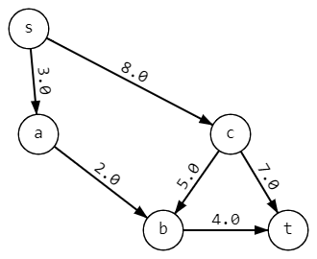Найти максимальный поток и минимальный разрез данного графа алгоритмом Форда-Фалкерсона

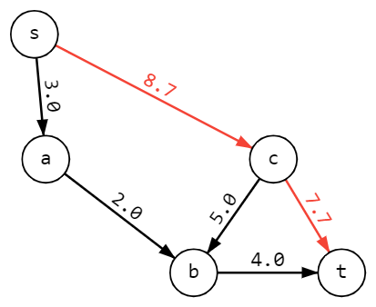

|  |  |  |  |  |  |
| --- | --- | --- | --- | --- | --- |
| Итерация | s | a | b | c | t |
| 1 | [+s, ∞] | [+s,3] | [+c,5] | [+s,8] | [+c,7] |

v=7

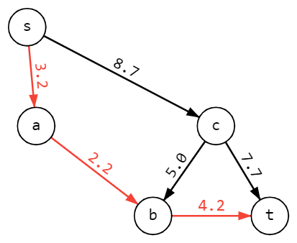

|  |  |  |  |  |  |
| --- | --- | --- | --- | --- | --- |
| Итерация | s | a | b | c | t |
| 2 | [+s, ∞] | [+s,3] | [+a,2] | [+s,1] | [+b,2] |

v=9

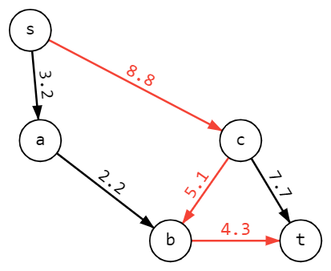

|  |  |  |  |  |  |
| --- | --- | --- | --- | --- | --- |
| Итерация | s | a | b | c | t |
| 3 | [+s, ∞] | [+s,1] | [+c,1] | [+s,1] | [+b,1] |

v=10

|  |  |  |  |  |  |
| --- | --- | --- | --- | --- | --- |
| Итерация | s | a | b | c | t |
| 4 | [+s, ∞] | [+s,1] |  |  |  |

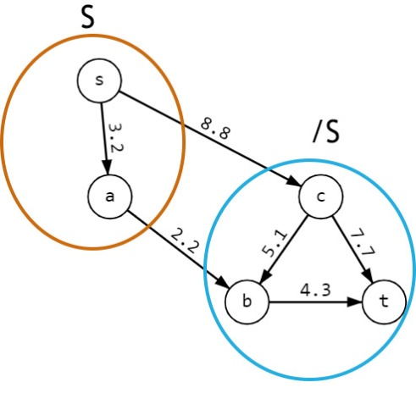

v=10

Дальнейшая разметка невозможна

S={s,a}, /S={b,c,t}, разрез (S,/S) = {ab,sc}

c(ab)+c(sc)=2+8=10=v

**Максимальный поток графа = 10**